**Pecking order:** (priority of use; highest priority first)

1. Users of the MRL that made a booking in the calendar (see QR code).
2. Users of the MRL that did not make a booking in the calendar.
3. Everyone else.

**The obvious:**

Please keep this space clean! Restore the original setup before you leave. In particular:

* Remove all objects from the tracking volume after use.
* If you re-wired monitors, network, or keyboards, put them back to where they were.
* Put robots back to their parking spot and charge batteries in the fire-proof cabinet.

**Thanks! :) Happy hacking!**

See the **lab-wiki** for usage and safety instructions:

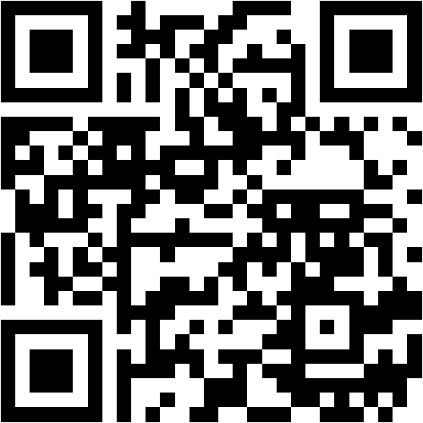

<https://github.com/cor-mobile-robotics/lab-wiki>